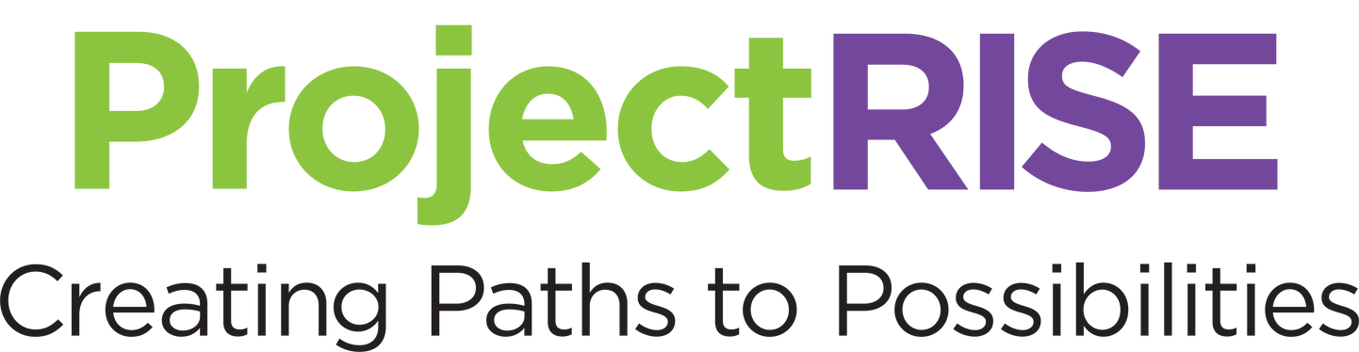

REACH. INSPIRE. SUSTAIN. EMPOWER.
Cohort #21 January 6, 2025- February 7, 2025
Orientation: Friday, January 3rd 9:00AM – 11:00AM
Start Date: Monday, January 6th
NO CLASS: Thurs-January 9th- IDignity
Monday, January 20th (MLK DAY OBSERVED)
Wednesday, January 29th - Orlando Mayor’s Job Fair (12 pm-4 pm)
Mon-Wed, February 3rd-5th - Employer Mock Interviews- 9am-2pm
Friday, February 7th - Graduation 1PM-2PM

Cohort #22 February 24, 2025- March 28, 2025
Orientation: Friday, February 21st 9:00AM – 11:00AM
Start Date: Monday, February 24th
NO CLASS: Thurs-March 13th- IDignity
Wednesday, March 19th - Central Florida Job Fair (12 pm-4 pm)
Thursday, March 20th - Graduation -1PM-2PM
Mon-Wed, March 24th-26th - Employer Mock Interviews- 9am-2pm

Cohort #23 April 14, 2025- May 16, 2025
Orientation: Friday, April 11th 9:00AM – 11:00AM
Start Date: Monday, April 14th
Friday, April 18th (GOOD FRIDAY OBSERVED)
NO CLASS: Thurs-May 8th- IDignity
Mon &Tues- May 12th, May 13th - Employer Mock Interviews- 9am-2pm
Wednesday, May 14th - Central Florida Job Fair (12 pm-4 pm)
Friday, May 16th - Graduation 1PM-2PM

Cohort #24 June 2, 2025- July 3, 2025
Orientation: Friday, May 30th 9:00AM – 11:00AM
Start Date: Monday, June 2nd
Thursday, June 19th (JUNETEENTH OBSERVED)
Mon-Wed, June 30th-July 2nd - Employer Mock Interviews- 9am-2pm
Thursday, July 3rd - Graduation 1PM-2PM

Cohort #25 July 21, 2025- August 22, 2025
Orientation: Friday July 18th 9:00AM – 11:00AM
Start Date: Monday, July 21st
Mon-Wed, August 18th-20th - Employer Mock Interviews- 9am-2pm
Friday, August 22nd - Graduation -1PM-2PM

Cohort #26 September 8, 2025- October 10, 2025
Orientation: Friday, September 5th 9:00AM – 11:00AM
Start Date: Monday, September 8th
Wednesday, September 10th - Central Florida Job Fair (12 pm-4 pm)
NO CLASS: Thurs-September 11th – IDignity
Mon-Wed, October 6th-8th - Employer Mock Interviews- 9am-2pm
Friday, October 10th - Graduation -1PM-2PM

Cohort #27 October 27, 2025- November 21, 2025
Orientation: Friday, October 24th 9:00AM – 11:00AM
Start Date: Monday, October 27th
Wednesday, October 29th - Central Florida Job Fair (12 pm-4 pm)
NO CLASS: Thurs-November 13th – IDignity
Mon-Wed, November 17th-19th - Employer Mock Interviews- 9am-2pm
Friday, November 21st - Graduation -1PM-2PM

Cohort #28 December 8, 2025-January 9, 2026 (TBD)
Orientation: Friday, December 5th 9:00AM – 11:00AM
Start Date: Monday, December 8th
Dec 24th and 25th (CHRISTMAS EVE, CHRISTMAS DAY OBSERVED)
Thursday, January 1st (NEW YEARS DAY OBSERVED)
Mon-Wed, January 5th-7th - Employer Mock Interviews- 9am-2pm
Friday, January 9th - Graduation -1PM-2PM

Disclaimer:
Classes are held Monday through Friday from 9:00 AM to 2:00 PM, with morning sessions focusing on Emotional Intelligence and afternoon sessions on JAWS (Job Acquisition Workplace Skills). The final week of the cohort includes employer engagement opportunities, such as mock interviews. Please note that while we strive to assist all participants in their employment journey, job placement is not guaranteed.

